**Critical Thinking Assignment 1: Option 2**

Jeremy Carney

Colorado State University Global

CSC372: Programming II

Santosh Gottipamula

May 18th, 2025

**Introduction**

Object-oriented programming is a fundamental concept in software development. This paper demonstrates these principles by implementing a Java application with a super lass Employee and a subclass Manager, along with a test class to showcase inheritance and polymorphism. The project transitions from class design to code implementation, reinforcing key programming concepts for a second-year programmer.

**Methodology**

The project involves creating three Java classes: Employee, Manager, and EmployeeTest. The Employee class includes fields for firstName, lastName, employeeID, and salary, with a constructor initializing salary to zero, setters and getters for firstName, lastName, em ployeeID, and salary, and an employeeSummary method to print all attributes. The Man ager class extends Employee, adding a department field and overriding employeeSummary to include the department. The EmployeeTest class creates instances of both classes, sets their attributes, and calls employeeSummary to display the results.

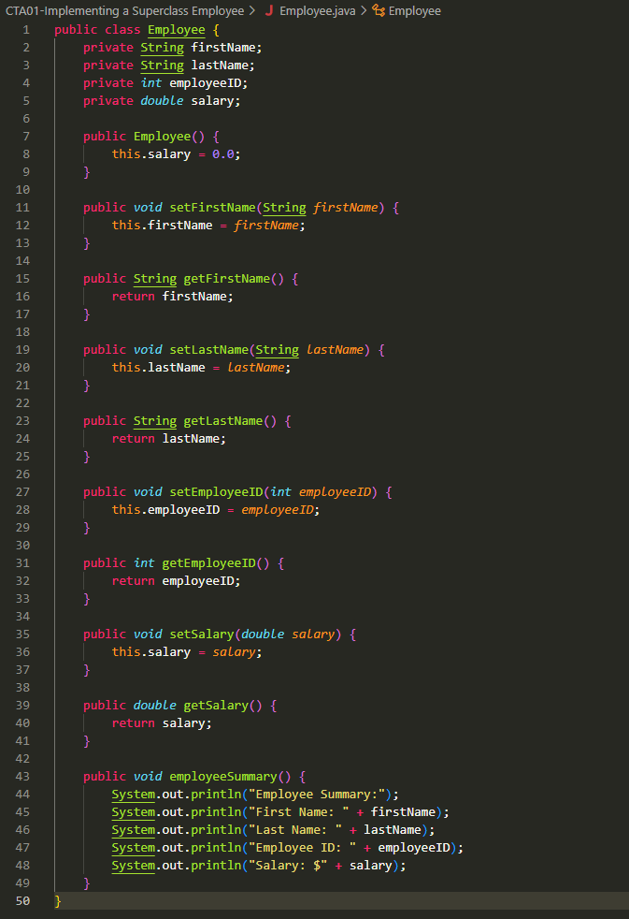

Figure : Employee.java

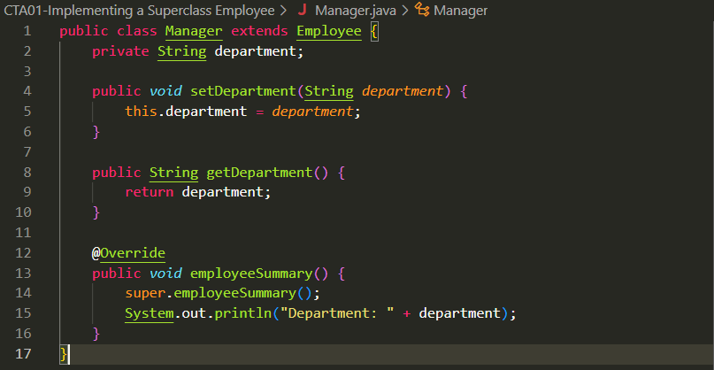

Figure : Manager.java

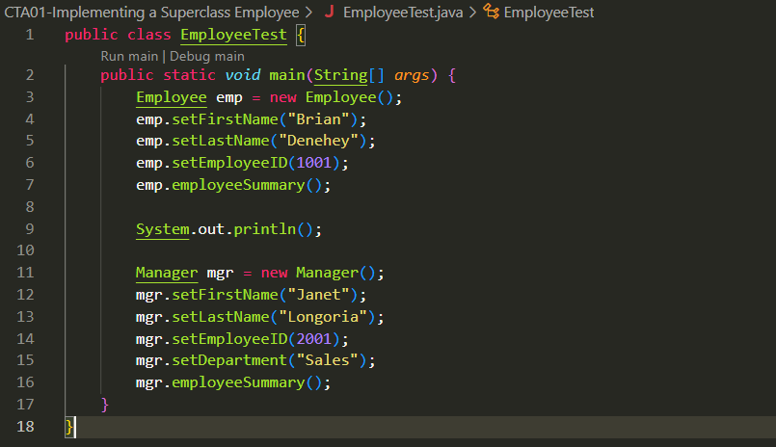

Figure : EmployeeTest.java

**Results**

The output of the EmployeeTest class displays the attributes of an Employee object (e.g., ”Brian Denehey, ID: 1001, Salary: $0.0”) and a Manager object (e.g., ”Janet Longoria, ID: 2001, Salary: $0.0, Department: Sales”). Each attribute is printed on a separate line, demonstrating the inheritance and method overriding functionality.

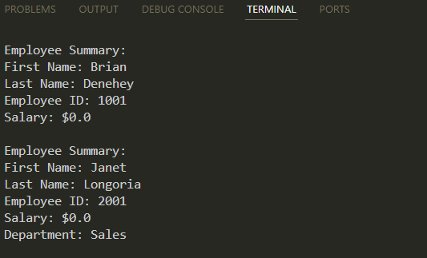

Figure : Output of EmployeeTest class.

**Discussion**

Developing the Employee and Manager classes reinforces object-oriented programming concepts such as encapsulation, inheritance, and polymorphism. The use of getters, setters, and method overriding provides hands-on experience with Java syntax and class relationships.

**References**

GITHUB: <https://github.com/FistanRaist/CSC372-Programming-II>

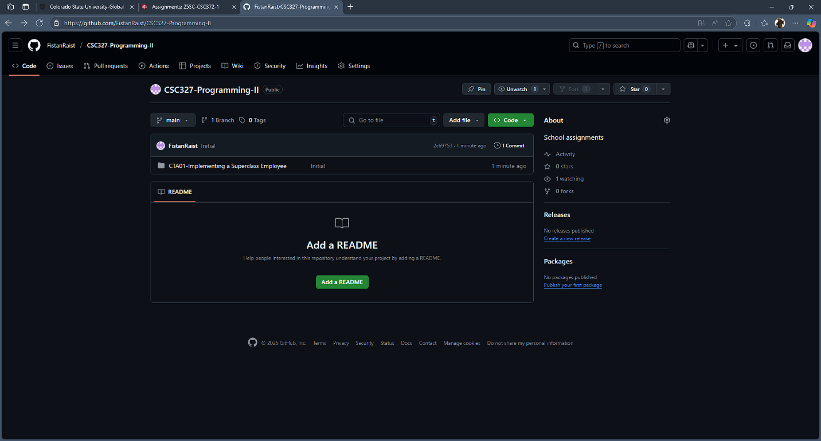

Figure : https://github.com/FistanRaist/CSC372-Programming-II